Healthy, Gluten Free Kale & Apple Chicken Soup

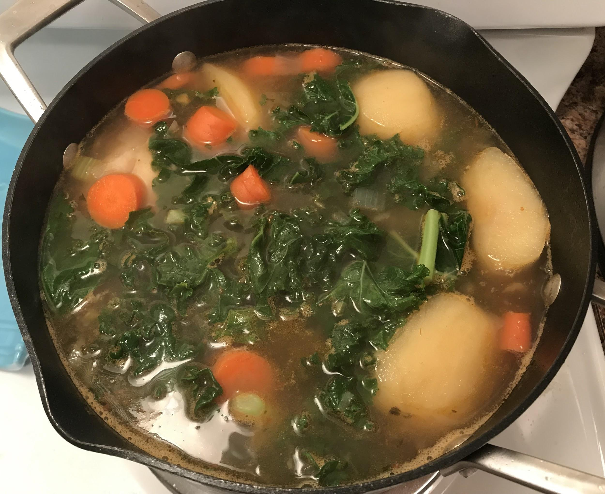

Growing up, my family always had bone broth before and after every meal. Every day was a different soup and each soup served a different purpose such as to detox, decrease a cough, increase energy or just for general immune function. One of my favorite bone broths included apples and papayas. However, papayas can often be hard to find in Western PA. Recently, I developed my own recipe that includes apples and kale.

This makes the perfect soup for winter to prevent colds and flu. It is packed with nutrients. Kale is a great source of calcium, vitamins C and K and lutein. In addition, to being an amazing fiber, antioxidant, and anti-inflammatory.

Apples are another great source of Vitamin C to boost your immune system. In addition, it also contains potassium and chromium. It is also a powerful antioxidant, anti-inflammatory and contains lots of fiber.

Both kale and apples are so nutritious that they’re known to reduce cholesterol, prevent diabetes, increase weight loss, protect against cancer, and improve bone and brain health among numerous other benefits.

Ingredients:
2 organic chicken drumsticks
1 bunch of organic kale
2 organic apples (any type), cut in quarters
1 pound of organic carrots
4 cloves of chopped garlic
2-3 sprigs of thyme
32 oz of chicken broth
32oz of water
1 tbsp of fresh lemon juice (optional)
¼ cup of Goji berries (optional)

Instructions:
- (Optional - for more flavor). Marinate the chicken drumsticks with lemon (optional) salt & pepper for about 30 minutes
- On medium heat, heat up the olive oil, add the chicken drumsticks, onion and garlic for about 3 minutes.
- Once chicken is browned on the outside, add chicken stock and water. Bring it to a boil, and lower heat.
- Add the carrots, celery, apples and thyme. Cook until carrots are tender.
- You may add potatoes, cooked rice or gluten-free pasta. If adding potatoes, add them 5 minutes after the previous step. Pasta can be added in the last 5-10 minutes.
- Add goji berries if desired and cook for one minute.
- Add more salt and pepper to taste
- Remove bones from chicken and cut the meat into smaller pieces

